**Installing WLAN APs**

Student Version



Huawei Technologies Co., Ltd.

|  |
| --- |
| **Copyright © Huawei Technologies Co., Ltd. 2020. All rights reserved.**  No part of this document may be reproduced or transmitted in any form or by any means without prior written consent of Huawei Technologies Co., Ltd.  **Trademarks and Permissions**  HW_POS_RBG_Vertical-150ppi.png and other Huawei trademarks are trademarks of Huawei Technologies Co., Ltd.  All other trademarks and trade names mentioned in this document are the property of their respective holders.  **Notice**  The purchased products, services and features are stipulated by the contract made between Huawei and the customer. All or part of the products, services and features described in this document may not be within the purchase scope or the usage scope. Unless otherwise specified in the contract, all statements, information, and recommendations in this document are provided "AS IS" without warranties, guarantees or representations of any kind, either express or implied.  The information in this document is subject to change without notice. Every effort has been made in the preparation of this document to ensure accuracy of the contents, but all statements, information, and recommendations in this document do not constitute a warranty of any kind, express or implied. |

|  |  |
| --- | --- |
| Huawei Technologies Co., Ltd. | |
| Address: | Huawei Industrial Base  Bantian, Longgang  Shenzhen 518129  People's Republic of China |
| Website: | <https://e.huawei.com/> |

**Huawei Certification System**

Huawei Certification follows the "platform + ecosystem" development strategy, which is a new collaborative architecture of ICT infrastructure based on "Cloud-Pipe-Terminal". Huawei has set up a complete certification system consisting of three categories: ICT infrastructure certification, platform and service certification, and ICT vertical certification. It is the only certification system that covers all ICT technical fields in the industry. Huawei offers three levels of certification: Huawei Certified ICT Associate (HCIA), Huawei Certified ICT Professional (HCIP), and Huawei Certified ICT Expert (HCIE). Huawei Certification covers all ICT fields and adapts to the industry trend of ICT convergence. With its leading talent development system and certification standards, it is committed to fostering new ICT talent in the digital era, and building a sound ICT talent ecosystem.

Huawei Certified ICT Associate-Datacom (HCIA-Datacom) is designed for Huawei's frontline engineers and anyone who want to understand Huawei's datacom products and technologies. The HCIA-Datacom certification covers routing and switching principles, basic WLAN principles, network security basics, network management and O&M basics, SDN and programmability and automation basics.

The Huawei certification system introduces the industry, fosters innovation, and imparts cutting-edge datacom knowledge.

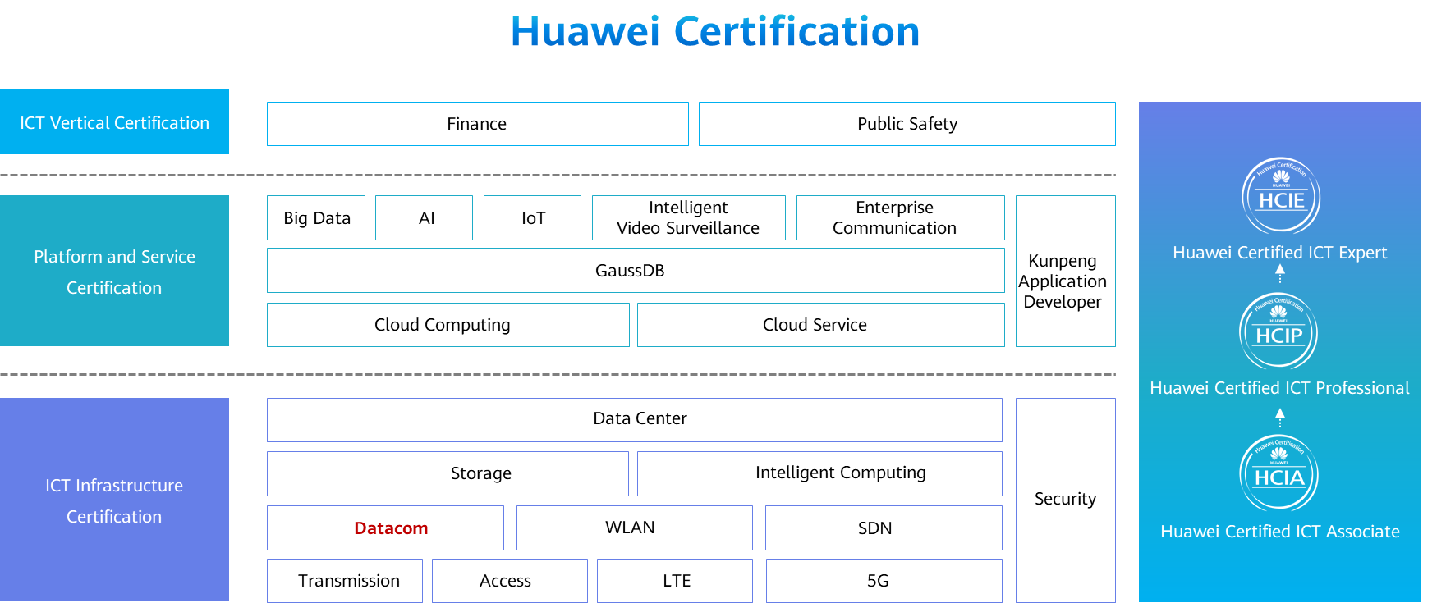

# Installing WLAN APs

## Background

Access points (APs) are core devices on a WLAN, which act a bridge to wired networks. This exercise describes how to install an AirEngine 5760-10. Figure 1-1 shows its appearance. Upon completion of this course, students will be able to understand the AP's hardware structure and know how to install APs.

Appearance of the AirEngine 5760-10

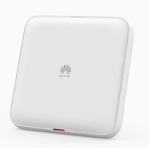

## Objectives

Upon completion of this task, you will be able to:

Know the AP's appearance.

Understand the AP's hardware structure.

Know the process for installing APs.

Understand AP installation precautions.

## Planning

This exercise aims to get you familiar with APs and help you learn how to install APs, laying a foundation for onsite O&M.

Before the installation, take safety measures to prevent personal injuries and device damage, and prepare installation tools.

Determine the installation position of an AP following specified rules.

Mount the AP on the wall.

Connect the Ethernet cable and power cable of the AP.

Connect the AP to a fixed object through its security lock for anti-theft purposes.

After the installation is complete, verify that the installation meets the requirements listed in the installation checklist.

Power on the AP and check whether the AP starts properly.

**----End**

## Implementation

Preparations

Safety precautions

1. Take proper measures to prevent injuries and device damage.
2. Place the device in a dry and flat position away from any liquid and prevent the device from slipping.
3. Keep the device clean.
4. Do not put the device and tools in the aisles.

Tool preparation

Phillips screwdriver, protective gloves, ESD gloves, slip-proof gloves, marker, hammer drill, claw hammer, torque wrench, diagonal pliers, wire stripper, crimping pliers, network cable tester, multimeter, ladder, safety helmet, safety belt, anti-skid shoes, and torque screwdriver

Determine the installation position.

Indoor APs are installed on walls or ceilings using mounting brackets. The installation positions are determined based on site survey results. A minimum of 200 mm (7.87 in.) clearance must be reserved between the cable outlet and the wall, as shown in Figure 1-2.

Reference AP installation positions

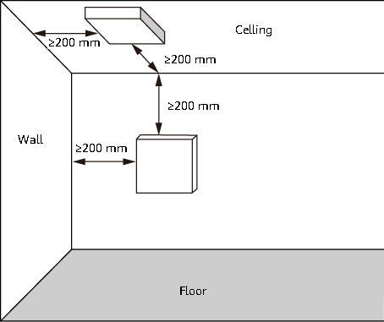

When determining the installation position of an AP, comply with the following rules:

Minimize the number of obstacles (such as walls) between the AP and STAs.

Keep the AP away from electronic devices that may cause radio interference, such as microwave ovens, other APs, and antennas. For details, see Table 1-1.

Install the AP in a hidden place and ensure that it does not disturb daily work and life of residents.

Install the AP at a site that is free from leaking or dripping water, heavy dew, and humidity, and take protective measures to prevent water from flowing into the AP along the cable.

Do not install the AP in an environment with high temperature, dust, poisonous gases, flammable or explosive objects, electromagnetic interference (from a radar station, radio station, or substation), unstable voltage, violent shakes, or strong noise.

General requirements for the anti-interference distance of antennas

|  |  |
| --- | --- |
| **Item** | **Requirement** |
| Indoor installation scenario | 1. The distance between antennas is greater than 7 m. 2. The distance from antennas of the carrier is greater than 5 m. 3. Antennas are far away from other electronic devices (such as microwave ovens) that may cause antenna interference. |

Connect cables.

Figure 1-8 and Table 1-2 describes the cable connections. When installing a cable, you must make a drip loop to prevent water from flowing into the AP along the cable. Pay attention to the following points when bundling the cables:

Different types of cables must be separately routed with the minimum spacing of 30 mm and cannot be entangled or crossed. Cables should be parallel or separated using dedicated separators.

Bundled cables are closely arranged, straight, tidy, and undamaged.

Cable ties are bound neatly facing the same direction, and those at the same horizontal line must be in a straight line. Cable tie tails should be cut smoothly and evenly.

Labels or nameplates must be attached to the cables after they are installed.

Cable connections

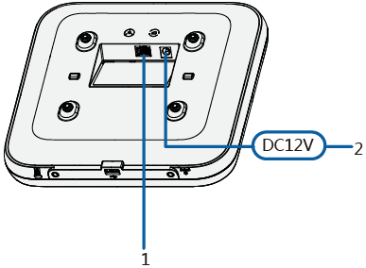

Cable connections

| **No.** | **Cable or Device** | **Description** |
| --- | --- | --- |
| 1 | Ethernet cable | 1. CAT5e cables or higher must be used. The Ethernet cable length cannot exceed 100 m. 2. If the AP needs to connect to the Ethernet, ensure that the Ethernet cable is working properly. If the Ethernet cable is not working properly, for example, RJ45 connectors are short-circuited, the AP may fail to be powered on or fail to work. Before connecting an Ethernet cable to the AP, use the cable test tool to check whether the cable is qualified. If the cable is unqualified, replace it. |
| 2 | DC power adapter | When the AP uses the DC power supply, use a power adapter for power supply; otherwise, the AP may be damaged. |

Install the AP.

Mount the AP on a wall. This mounting mode imposes the following requirements for the wall:

The wall can bear the weight of four times the total weight of the AP and mounting bracket without damage. When the total weight of the device and mounting brackets is 1.25 kg or less, the load-bearing capability of the wall must be greater than or equal to 50 N.

When the tightening torque of a screw reaches 3.5 N·m, the screw still properly works, without crack or damage on the wall.

In this mounting mode, the mounting bracket and expansion bolts are required. When securing the mounting bracket, ensure that the arrow in the https://support.huawei.com/hedex/pages/DOC1100305209AZH0312X/08/DOC1100305209AZH0312X/08/resources/dc/images/arrows_label02.png label points upwards. The installation procedure is as follows:

1. Attach the mounting bracket against the wall and adjust its position properly. Mark positions of the mounting holes with a marker, as shown in Figure 1-3.

Marking positions of mounting holes

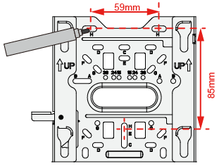

1. Use a 6 mm drill bit to drill 35 mm to 40 mm deep holes in the marked positions. Hammer the expansion tubes into the holes until the expansion tubes are completely embedded into the wall, as shown in Figure 1-4.

Drilling holes in the marked positions

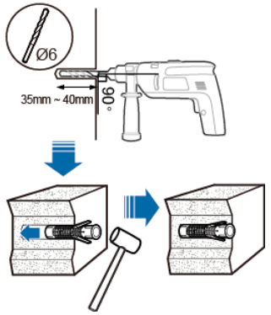

1. sFix the mounting bracket to the wall and use the Phillips screwdriver to fasten three expansion screws into the expansion tubes to secure the mounting bracket, as shown in Figure 1-5.

Securing the mounting bracket to the wall

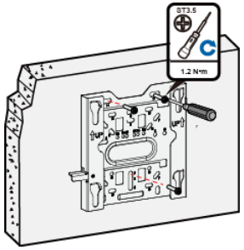

1. Connect and properly sort the cables, as shown in Figure 1-6.

Sorting the cables

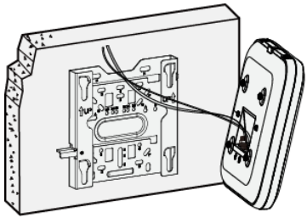

1. Align the rubber feet of the AP over the mounting slots on the mounting bracket and vertically push the AP. Press the AP downwards to secure it When you hear a click, the AP is secured on the mounting bracket, as shown in Figure 1-7.

Fixing the AP

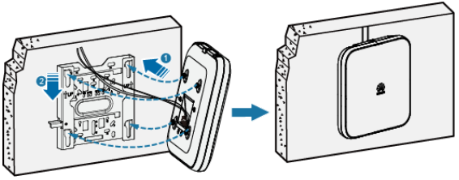

1. After the AP is installed, ensure that the release lever springs back in place. Ensure that the installation space meets the specified requirements to facilitate future maintenance.

Connect the security lock.

There is a security slot on the AP, as shown in Figure 1-9. You can lock the AP to an immovable object to prevent theft. The detailed procedure is as follows:

Fasten the cable of the security lock to an immovable object around.

Insert the security lock into the security slot and lock it.

Connecting the security slot

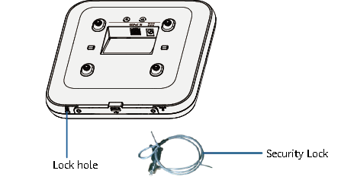

Verify the installation.

Table 1-3 shows the items to be checked after installation is complete.

Post-installation checklist

| **No.** | **Item** |
| --- | --- |
| 1 | The position for the device conforms to the engineering drawing and meets the space requirement. Sufficient space is reserved for device maintenance. |
| 2 | The device is securely installed. |
| 3 | Power cables are intact and not spliced. |
| 4 | The connectors of the power cables are securely soldered or crimped. |
| 5 | All power cables are not short-circuited or reversely connected, and are intact with no damage or cracks. |
| 6 | Power cables and ground cables are separated from other cables and bundled separately. |
| 7 | Working ground and protection ground of the device and lightning protection ground of the building share one group of grounding conductors. |
| 8 | The connectors for signal cables are intact and securely connected, and signal cables are not damaged or broken. |
| 9 | Labels are correct, legible, and complete. Labels at both ends of cables, feeders, and jumpers are correct. |

Power on the AP.

After the AP is powered on, observe the indicator on the AP to determine the system running status. Table 1-4 describes the meanings of the indicator states. When the AP is working properly, the indicator blinks white slowly.

Indicator status description

| **Silkscreen** | **Indicator Name** | **Color** | **Status** | **Description** |
| --- | --- | --- | --- | --- |
| Indicator | - | White | Steady on | Default status after power-on.  The AP is just powered on and the software is not started yet. |
| - | White | Steady on after blinking once | Software startup status.  After the system is reset and starts uploading the software, the indicator blinks white once. Until the software is uploaded and started, the indicator remains steady white. |
| - | White | Blinking once every 2s (0.5 Hz) | Running status.   1. The system is running properly, the Ethernet connection is normal, and STAs are associated with the AP. 2. The system enters the Uboot CLI. |
| Blinking once every 5s (0.2 Hz) | Running status.  The system is running properly, the Ethernet connection is normal, and no STA is associated with the AP. The system is in low power consumption state. |
| - | White | Blinking once every 0.25s (4 Hz) | Alarm.  The software is being upgraded.   1. After the software is loaded and started, the AP works in Fit or cloud mode and requests to go online. The indicator remains in this state till the AP successfully goes online. 2. The AP works in Fit or cloud AP mode and fails to go online. |
| - | Red | Steady on | Fault.  A fault that affects services has occurred, such as a DRAM detection failure or system software loading failure. The fault cannot be automatically rectified and must be rectified manually. |

**----End**

## Project Result Records

Check the items listed in Table 1-3 and record the check results.

Record the indicator status after the AP is powered on, and determine whether the AP works properly.

**----End**